**CareNxt Use case diagram**

**FR-001: Patient Registration & KYC**

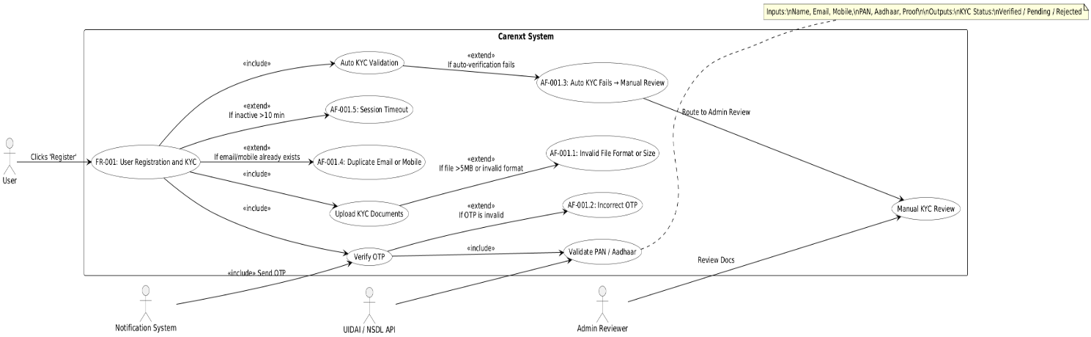

**FR-002: Doctor Schedule Setup**

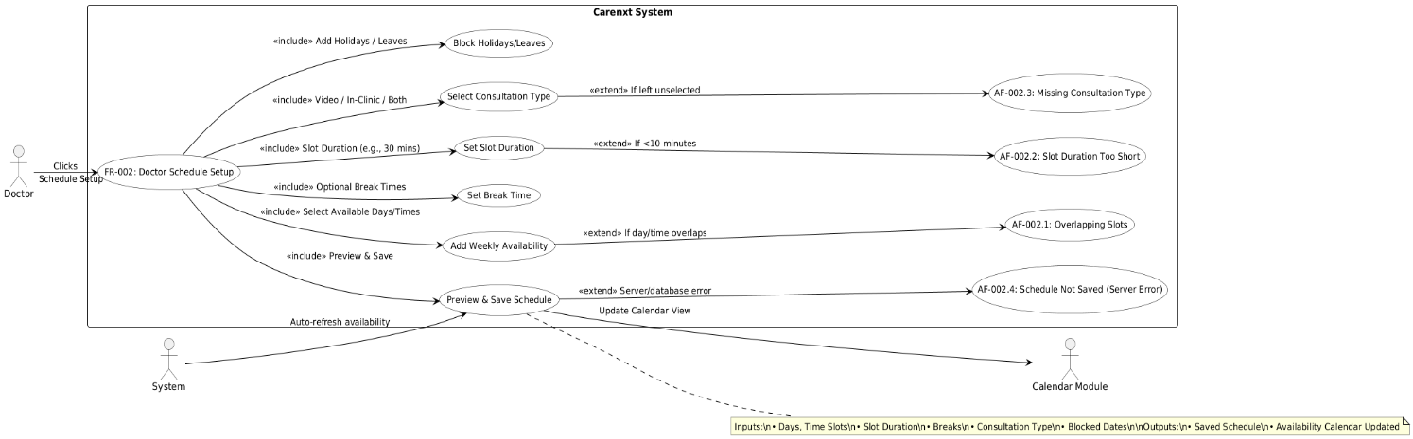

**FR-003: Appointment Booking**

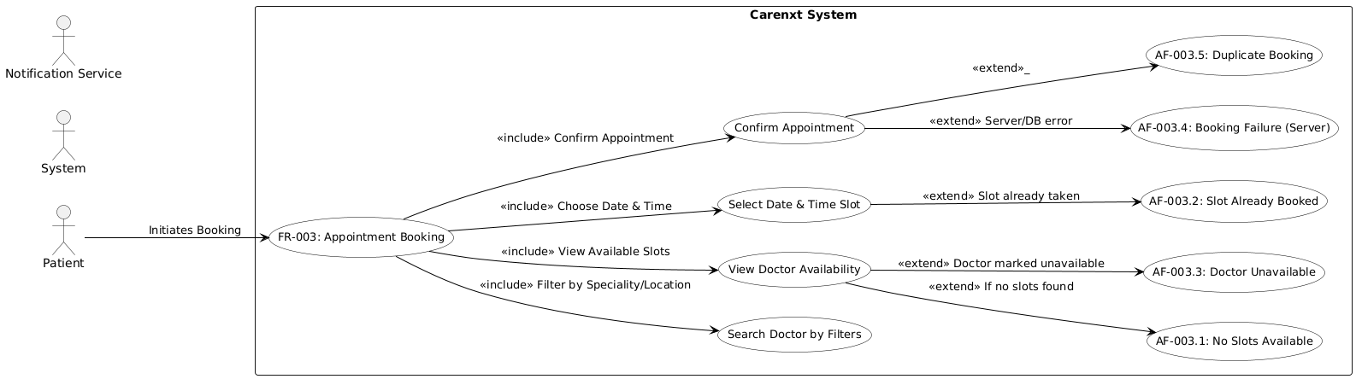

**FR-004: Consultation (Video/In-Clinic).**

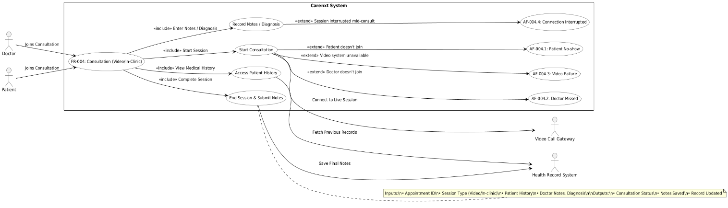

**FR-005: E-Prescription Generation.**

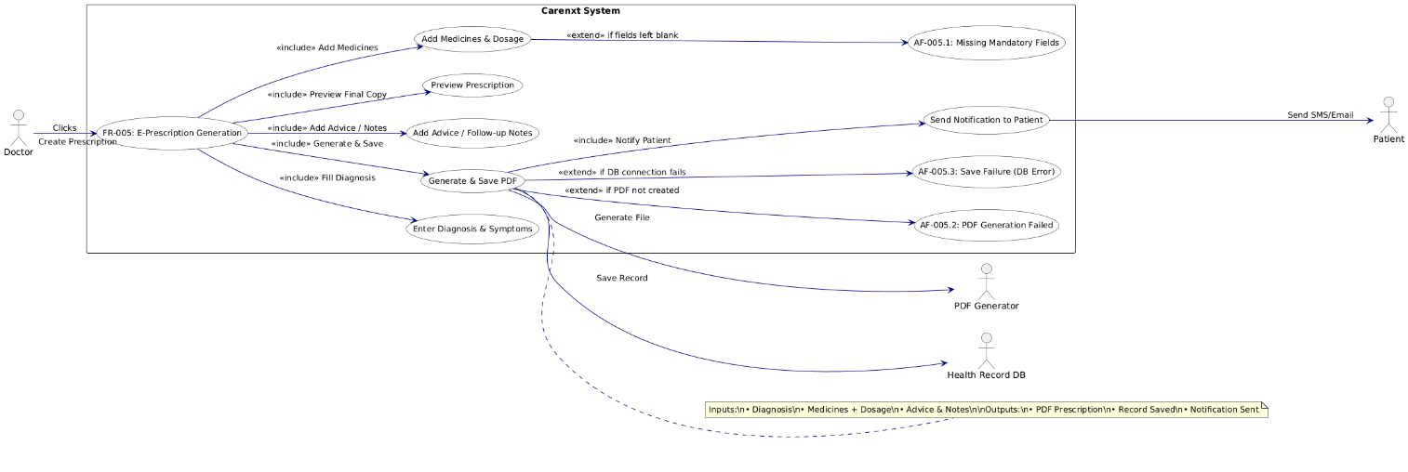

**FR-006: Medical History & Report Access.**

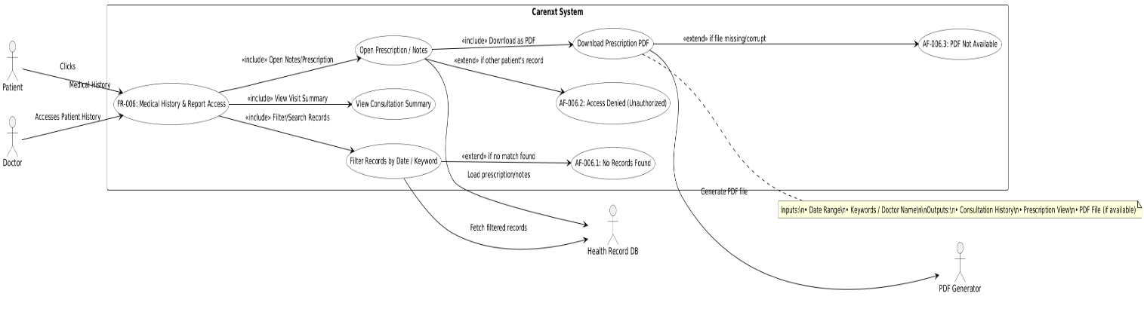

**FR-007: Notification & Reminder System**

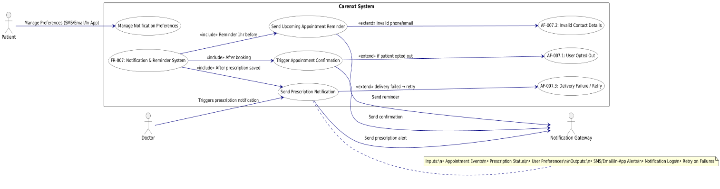

**FR-008: Admin Dashboard for Clinical Oversight**

